2006 ANNUAL DEPARTMENT BANQUET

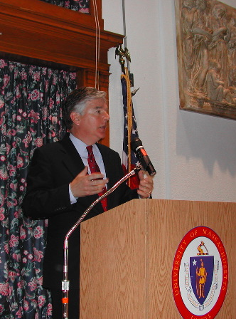

DISTINGUISHED ALUMNUS AND KEYNOTE SPEAKER
CONGRESSMAN MARTY MEEHAN (5th District)

Affilitated Professor
and Provost
John Wooding

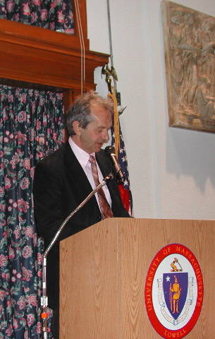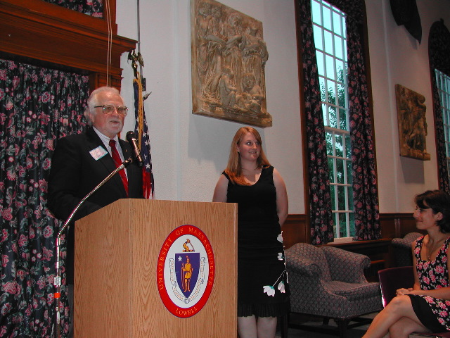

Carry Lemack of

“Families of
September 11th”

STUDENT AWARD WINNERS:

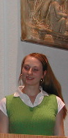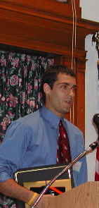

JILLIAN REDDING JOHN DRINKWATER

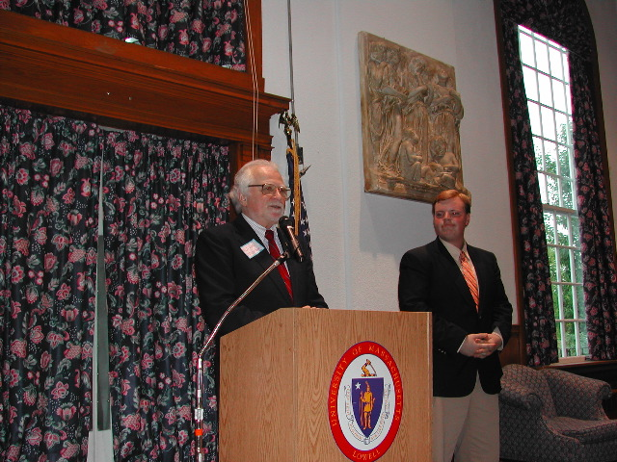
SEAN GARBALLEY KRISTINA HILTON
CHRIS ROBEY
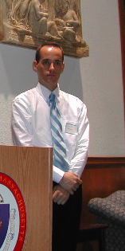

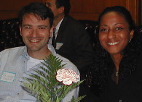

ANDREA ROSETTO AND WIFE ANNY

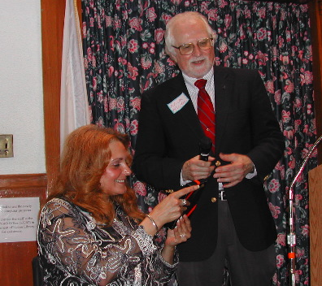

LINDA GIBSON & PROF. NICK MINTON

